**Homework 2**

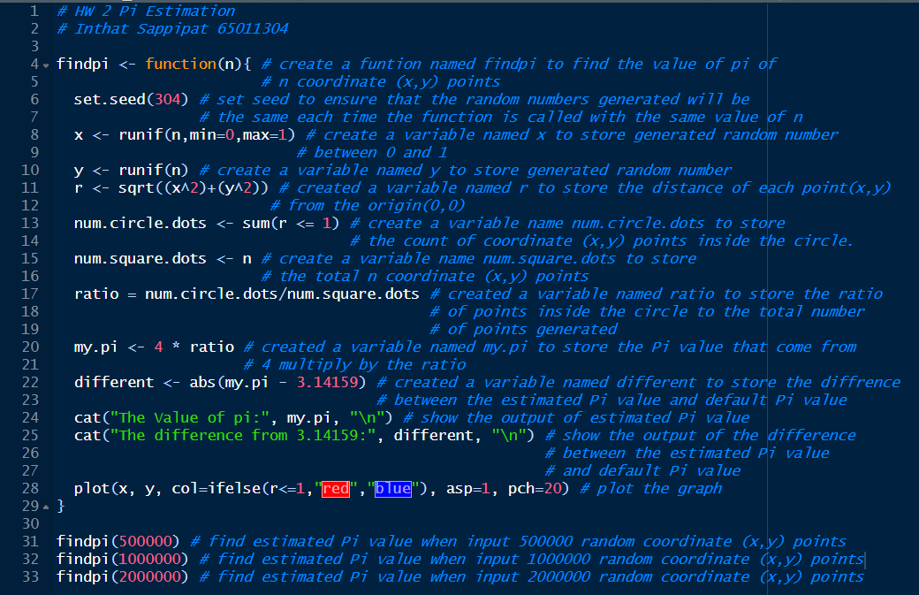**Code:**

**Result:**

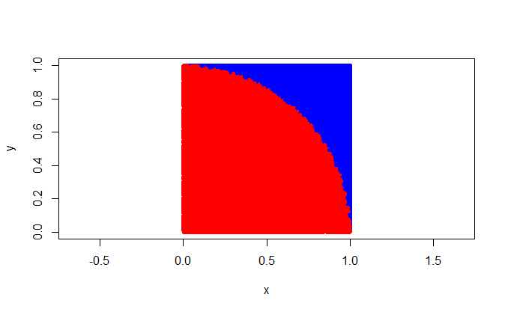**1.Findpi(500000):**

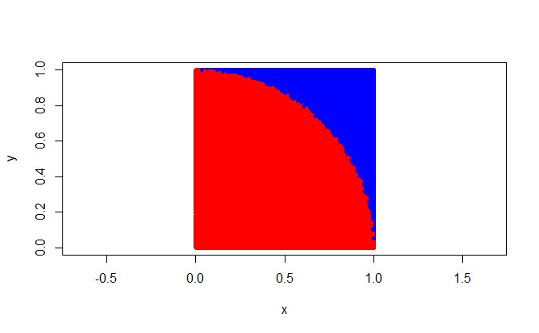**2.Findpi(1000000)**

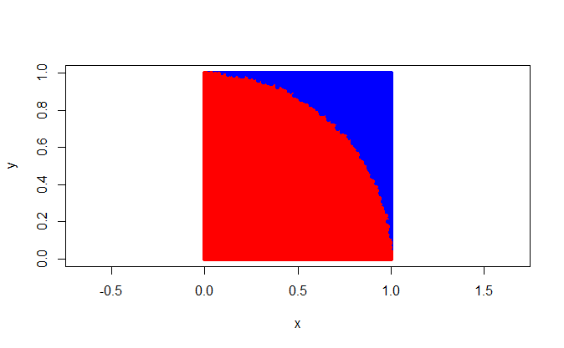**3.Findpi(2000000)**

**Result table:**

|  |  |  |
| --- | --- | --- |
| **Number of dots (n)** | **Pi value** | **Difference from 3.14159** |
| 500,000 | 3.14344 | 0.00185 |
| 1,000,000 | 3.14384 | 0.00225 |
| 2,000,000 | 3.14251 | 0.00092 |

**Conclusion:**

From the experiment, if we increase the number of dots, the Pi value seems to be closer to the classical Pi value (3.14159). In my opinion, increasing the number of random points will improve the accuracy and convergence of the estimation. Moreover, the ratio of the area of a quarter unit circle to the area of a unit square, which is π / 4, represents the relationship between the geometric properties of the circle and the square. I generate random points and compute ratios, allowing me to approximate the value of Pi.